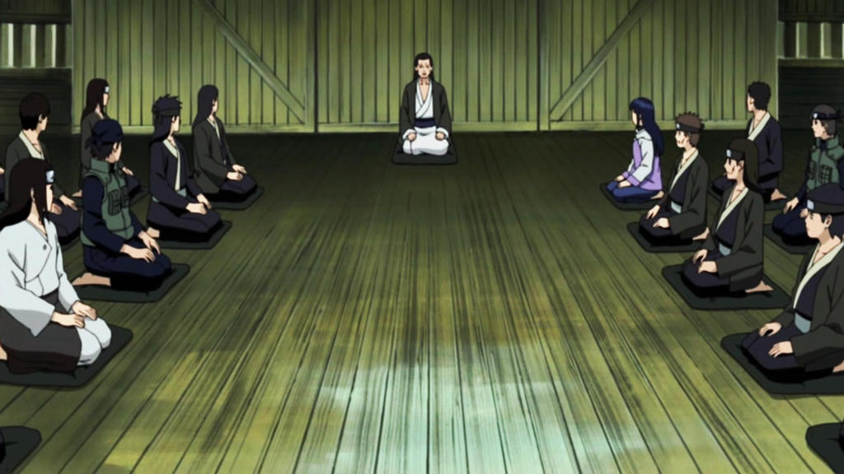

**Hyuuga Clan**

The Hyuuga (日向一族, Hyūga Ichizoku) is one of the three nobles of Watashitachi wa, Kizoku. They are renown for their visual prowess from their Dojutsu the Byakugan and their Crane Stance often referred to as the “Gentle Fist”. They are often known for their tranquil and pacifist like stance upon war and the Shinobi life, although they begrudgingly take it up for the greater good of their house.

History

**Preface**

The Hyuuga clan origin comes from a group of nomadic pacifists who roamed the land in search of Nirvana, a place said to be without pain and suffering of the earthly world. They would meditate the mind and train the body in attempts to reach this state, often performing rituals thought to separate their body from the current world and place them more closely to Nirvana. These would come in the form of fasting, intense exercise, and constant studying.

As these group of nomads continued to train amongst themselves, they were attacked by a group of Kaguya raiders, not caring for their pacifist ways and killing indiscriminately. One of the members by the name of Hei raised his hands against them, being one of the more prominent fighters he drove them back, taking a few of their numbers as well. Though he had saved the nomads, their current leader shunned him- saying those who spilled blood will never be allowed into Nirvana and exiled him from the pact.

He wondered The Isle alone and in fear that he would never enter Nirvana. This is when he was discovered by Asahi of the First Flame, who took him in and due to his courage and fighting skill. Hei continued to train and study, but unlike the others he would take up arms and fight along with Asahi. Hei had discovered the missing component to reaching Nirvana, true Nirvana was found in the midst of chaos and not by avoiding it. He developed white-eyes that were capable of seeing eyes, being named Hei Of Nirvana.

With his new found visual prowess he searched for and found his old pact. Spreading the news to them, though the leader thought this to be a trick and attempted to cast Hei out once more. Some followers came with Hei and just like him developed the eyes that would soon be named the Byakugan. Each time he would return to the pact with others baring the eyes and gain more followers until all that remained was a stubborn leader. Hei single handedly delivered his clan to their most promised Nirvana, or at least what real Nirvana he could offer.

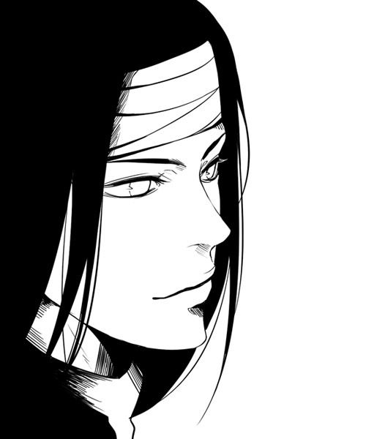

***Hei, Of Nirvana***

**Current**

The Hyuuga clan is currently learning to live a simpler life, usually being pampered by their vast wealth and fame they grew stagnant in their combat skills. Used to the finer things such as servants, well prepared meals, and warm cots, they are not accustomed to the life of a commoner but work each day to grow into their new role. They work tirelessly with the Senju and Uzumaki to restore their house to it’s former glory even if they have to do the work by hand alone.

Description

The Hyuuga are known to have completely white irises, giving their eyes the appearance to be blank white along with different dark shades of hair. They are known to wear robes and other clothing fit for nobles.

The Hyuuga pride their etiquette overall and kind and polite even towards enemy. They often take the proper steps and greet and speak to all with respect, though they see those who are not nobles as second-rate to them. They more so express this in a less rude way, but similar to the way a human would speak down to an animal, as if it couldn’t possibly understand what they were saying.

Player Guide

*Hyuuga are known to rarely ever lose their temper, they are known to show the upmost etiquette. Bowing when greeting someone and using the proper term to address them. Even thinking non noble clans are second-rate, they think even more lowly of those who do not have a clan at all. Hyuuga often walk and speak with the hubris of their former selves. Hyuuga are not accustomed to having to do for themselves and usually have servants to do the most common tasks, being clueless at things such as farming or handy-man work but still thinking themselves to be above the common man.*

-Hyuuga always share the same ocular appearance, contacts are never used by them.

-Hyuuga speak with full annunciation of words, giving them what others would call a “proper” accent.

-Hyuuga have impeccable etiquette, even when in combat and talking towards enemy.

-Hyuuga would rather refrain from combat, and enjoy things such as small quiet get togethers, hot tea, and games of wits.

-Hyuuga and Nara are the only two clans in history known to not harbor a grudge towards the others, being able to interact with each other normally even when in public.

-Hyuuga have an extremely advanced education, only second to the Uzumaki in depth. They have an advanced understand in all subjects, although they have very little talent when it comes to yardwork or farming, they have knowledge of the methods.

-Hyuuga’s diets are mostly fruit, plant, and wheat based. They are not vegetarians by means but meat isn’t as common in their meals as most other clans.